2024 “The Faces of 5p-“ Awareness Campaign

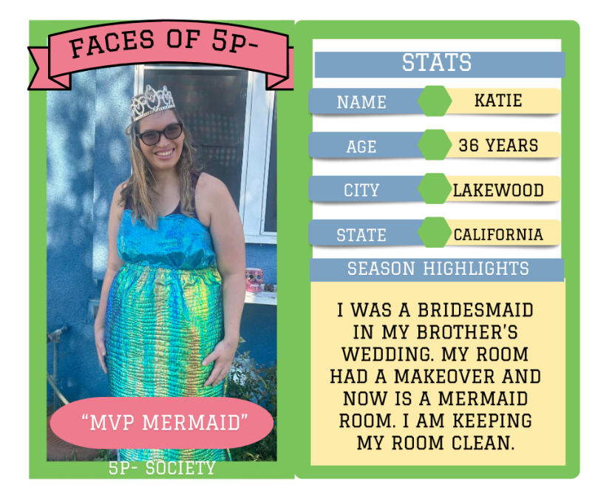
Join Us From Anywhere in the World!
We welcome families from around the globe to participate in this year's Awareness Week! As part of the festivities, we'll be creating trading cards featuring your MVP to fit the theme.
If you would like to participate, please submit your pictures (in Portrait format in either jpg or png), a few highlights that you’d like to share for the year (space is limited), what you’d like to proclaim they are MVP of, and the release form by April 25, 2024 to director@fivepminus.org.

We will begin to showcase the pictures on our Social Media pages each day during awareness week and beyond. The goal is to get enough pictures to put together an awareness campaign video slide show to use to promote and create awareness of the syndrome.

Please fill in the information below and submit with your picture:

Child/Adult’s name: ____________________________ Child/Adult’s birthday: ________________________________
Child/Adult’s age: _____________
Where your Child/Adult lives (City, State/Province, Country): ______________________________________________
Provide us with some highlights for the year: ___________________________________________________________ ________________________________________________________________________________________________
What is your Child/Adult MVP of: _____________________________________________________________________

(Copy and paste this info into your email, digital signatures are okay)

Photo Release:

I hereby release to the 5p‐ Society all proprietary rights and copyrights in all such photographs, digital images, voices, recordings, actions, films and likenesses (including negatives, positives and prints) of my child/adult ______________________________ which shall be and remain the property of the 5p‐ Society. I understand that this material may be used in various publications, public affairs releases, recruitment material, and broadcasts or for other related endeavors. This material may also appear on the 5p‐ Society’s website, and other public social media sites.

I expressly release the 5p‐ Society, its directors, officers, employees, agents and volunteers, from any and all claims, including copyright and privacy, arising out of any reproduction, broadcast, distribution, publication, or promotion of this event.

_________________________________________________
(Parent signature) (Date)

