**Awareness Week 2022**

**May 1-15**

**Awareness Week 2022**

**May 1-15**

Your body is made up of trillions of cells, too small to see, even with a microscope!

Inside these tiny cells are

23 pairs of chromosomes**,**

**that make you the person you are.** The information in your chromosomes determines your hair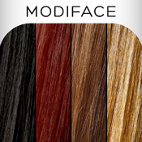 color, your eye 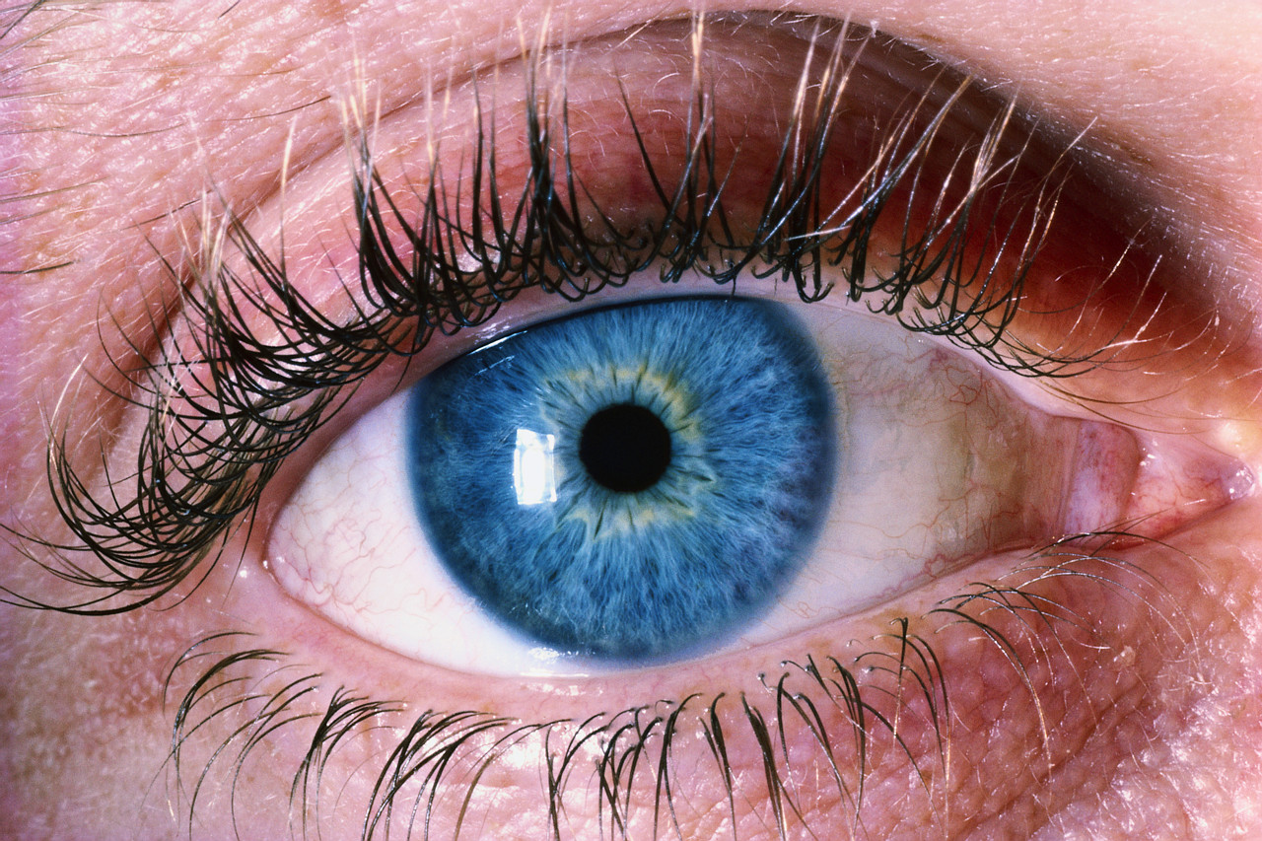color, how you grow, and all of the other things that you can do.

People with

Cri du Chat Syndrome

are missing a small part of Chromosome 5.

*It sometimes makes it tricky for them to do things, and it might take a little longer for them to learn to walk and talk.*

☺ Sometimes, they might need your help.☺

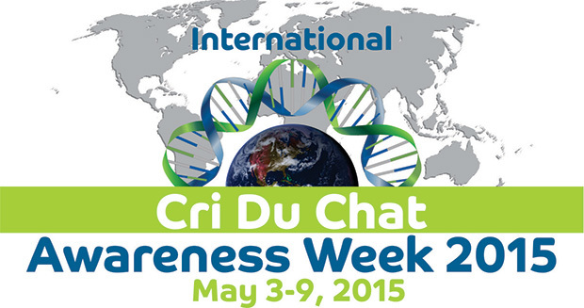

Your body is made up of trillions of cells, too small to see, even with a microscope!

Inside these tiny cells are

23 pairs of chromosomes**,**

**that make you the person you are.** The information in your chromosomes determines your hair color, your eye  color, how you grow, and all of the other things that you can do.

People with

Cri du Chat Syndrome

are missing a small part of Chromosome 5.

*It sometimes makes it tricky for them to do things, and it might take a little longer for them to learn to walk and talk.*

☺ Sometimes, they might need your help.☺

