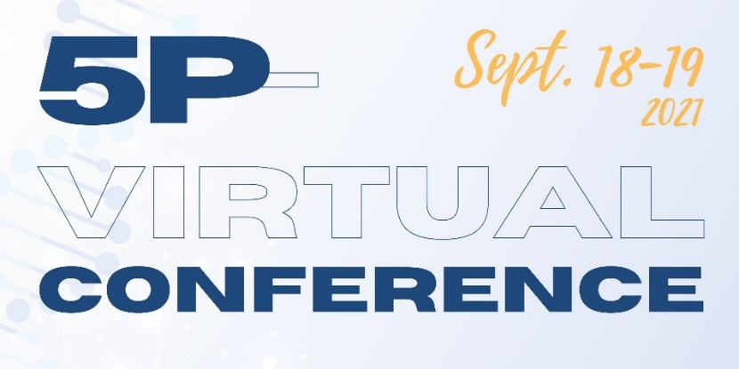
CONFERENCE AGENDA*
*Subject to Change
All times are in US Pacific and Eastern Times

SATURDAY, SEPTEMBER 18, 2021
9:00am – 9:50am PT  12:00pm – 12:50pm ET | Virtual Welcome  Nick Wallace, President 5p- Society  Meet a few of our very special friends
10:00am – 10:50am PT  1:00pm – 1:50pm ET | Genetics and Researching 5p- Syndrome  Sean Fox, Ph.D., Biomedical Sciences,  East Tennessee State University
11:00am – 11:50am PT  2:00pm – 2:50pm ET | 5p- Syndrome and Infections: Research Update  András Spaan, M.D., Ph.D.,  The Rockefeller Institute, New York
2:00pm – 2:20pm PT  5:00pm – 5:20pm ET | Virtual Coffee Break
12:00pm – 12:50 pm PT  3:00pm – 3:50pm ET | Physical Therapy and 5p- Syndrome: Research Findings  Laurel D. Abbruzzesse, PT, Ed.D,  Columbia University, New York
1:00pm – 1:50 pm PT  4:00pm – 4:50 pm ET | Cortical Visual Impairments and Neurological Vision Issues  Alex Olson & Lisa Linda, CVVI
2:30pm – 3:30pm PT  5:30pm – 6:30pm ET | Choose one  Mom’s Support Group  Dad’s Support Group
3:30pm – 4:30pm PT  6:30pm – 7:30pm ET | Dinner/Snack Break
4:30pm – 5:30pm PT  7:30pm – 8:30pm ET | Virtual Dance
5:30pm – 6:30pm PT  8:30pm – 9:30 pm ET | Virtual Social Hour

SUNDAY, SEPTEMBER 19, 2021
9:00am – 9:50am PT  12:00pm – 12:50pm ET | Welcome Back  Laura Castillo, Executive Director  Meet some of our very special individuals
10:00am – 10:50am PT  1:00pm – 1:50pm ET | Navigating Transition through Adulthood  Dennis Campbell, Ph.D., Chair Professional Advisory Board, Retired University of South Alabama
11:00am – 11:50am PT  2:00pm – 2:50pm ET | Effective Positive Behavior Therapy  AmySue Reilly, Ph.D., Retired, Auburn University
12:00pm – 12:20pm PT  3:00pm – 3:20pm ET | Virtual Coffee Break
12:30pm – 1:20pm PT  3:30pm – 4:20pm ET | Special Needs Trust v. ABLE Act  Kacey Seitz
1:30pm – 2:20pm PT  4:30pm – 5:20pm ET | Welcome to My World  Becky Owens, Board Member
2:30pm – 3:20pm PT  5:30pm – 6:20pm ET | Choose one  Medically Fragile – Translocation Parent Panel  Grandparent’s Support Group  Virtual Coffee Shop
3:30pm – 4:30pm PT  6:30pm – 7:30pm ET | Closing Session  Meet some of our very special individuals

For more information, please go to our 2021 Virtual Conference Website.
Click here to Register

